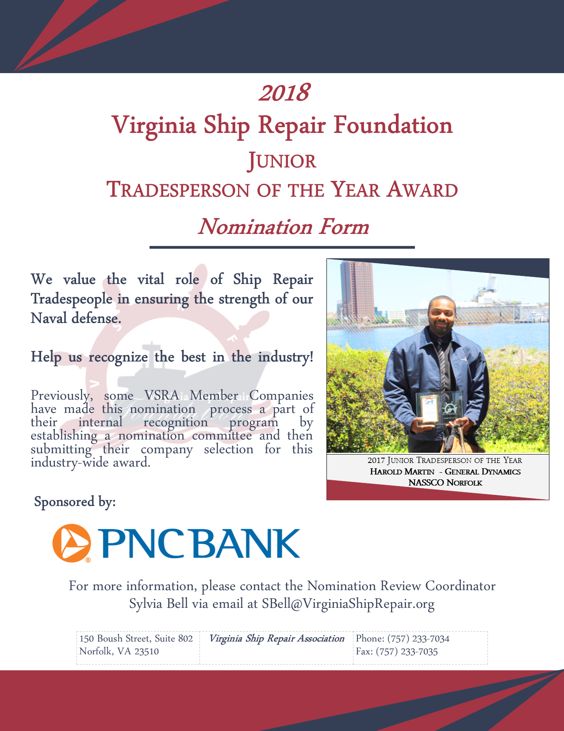
Virginia Ship Repair Foundation
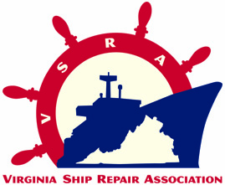
2018 JUNIOR TRADESPERSON OF THE YEAR
(Fewer than five years trade experience)
NOMINATION FORM
Only ONE Junior Tradesperson Nominee per company will be accepted.
INCOMPLETE NOMINATIONS WILL NOT BE CONSIDERED.
Please Note: This award is for recognition of a tradesperson; submissions for any non-tradesperson will not be considered. A tradesperson is a manual worker employed in a particular trade or craft requiring skill; this is contrasted with unskilled laborers and professionals (those in the learned profession).

Company Submitting Nomination: ___________________________________________________________
VSRA Member? YES☐ NO☐
Nominee’s Name: ________________________________________________________________________
Nominee’s Trade Area: ____________________________________________________________________
Fewer than 5 years in trade? YES☐ NO☐ (Note: Total experience, regardless of company affiliation)
Nominee’s Current Job Title: _______________________________________________________________
Nominee’s Jacket Size: Choose an item. Nominee’s Telephone Number: ____________________________
Nominator’s Name: _______________________________________________________________________ Nominator’s Job Title: _____________________________________________________________________
Nominator’s Email: ______________________________ Nominator’s Telephone Number: _____________
Please list the Nominee’s last three employers:
 | Company | Job Title | Duration of Employment
1 | Click here to enter text. | Click here to enter text. | Click here to enter text.
2 | Click here to enter text. | Click here to enter text. | Click here to enter text.
3 | Click here to enter text. | Click here to enter text. | Click here to enter text.

SUBMISSION INSTRUCTIONS
Submit your completed nomination form via email, fax, or mail to the attention of Sylvia Bell:
Email: SBell@VirginiaShipRepair.org
Fax: 757-233-7035
Mail: 150 Boush Street, Suite 802, Norfolk, VA 23510
Please submit this application form by: Friday April 20, 2018 at 5:00 PM. No extensions will be made to the deadline and late nominations will not be accepted! If you have any questions please contact Sylvia Bell at SBell@VirginiaShipRepair.org.
PART I: PERFORMANCE STANDARDS

Please comment on performance for each standard, describe how the nominee has excelled in their field, and be sure to cite specific examples.

- Demonstrates proficiency in area of expertise.
Click here to enter text.

- Consistently performs at the highest level of quality.
Click here to enter text.

- Seeks training and improvement opportunities to enhance trade and operational expertise; provide examples of professional development achievements (e.g.: certifications, training, and specialized skills); include attachments as needed
Click here to enter text.

- Maintains an exemplary safety record and instill safe working practices in co-workers / team.
Click here to enter text.

- Consistently shares expertise with less experienced co -workers.
Click here to enter text.

- Mentors less experienced workers on career development plans.
Click here to enter text.

- Shares feedback on improvements with supervisors.
Click here to enter text.

PART II: PROFESSIONAL REPRESENTATION OF THE SHIP REPAIR INDUSTRY

Please describe how the nominee has been a positive representation of the ship repair industry, and be sure to cite specific examples.

- Provide examples of leadership, mentorship, and/or role modeling; include reference letters and other attachments as needed.
Click here to enter text.

- Provide examples of creativity or innovation on the job; include attachments as needed.
Click here to enter text.

- Provide examples of how the Nominee has been recognized by the company, customers or other organizations, either formally or informally (for instance, e-mail commendation from the ship’s force); include attachments as needed.
Click here to enter text.

- Provide examples of Community Leadership Achievements.
Click here to enter text.

- Provide examples of how the Nominee has been an ambassador for the Ship Repair Industry in the community.
Click here to enter text.

PART III: COMPANY AWARD AGREEMENT
Per a decision by the Virginia Ship Repair Foundation, the awardee category will receive a VSRA embroidered jacket, $750.00 and awards. In addition, the company submitting this nomination form agrees to give the nominee time to attend the VSRA General Membership Luncheon on Tuesday, May 15, 2018 where the winner will be announced and if the employee is the winner time to attend the Annual National Maritime Day Reception. The company may decide, at their discretion, to allow the paid day off and allow the employee to attend the luncheon on a regularly scheduled work day. Nominees may bring one guest of their choosing to each of the events; companies cover additional seats at their expense.

Authorizing Company Representative Signature Date

