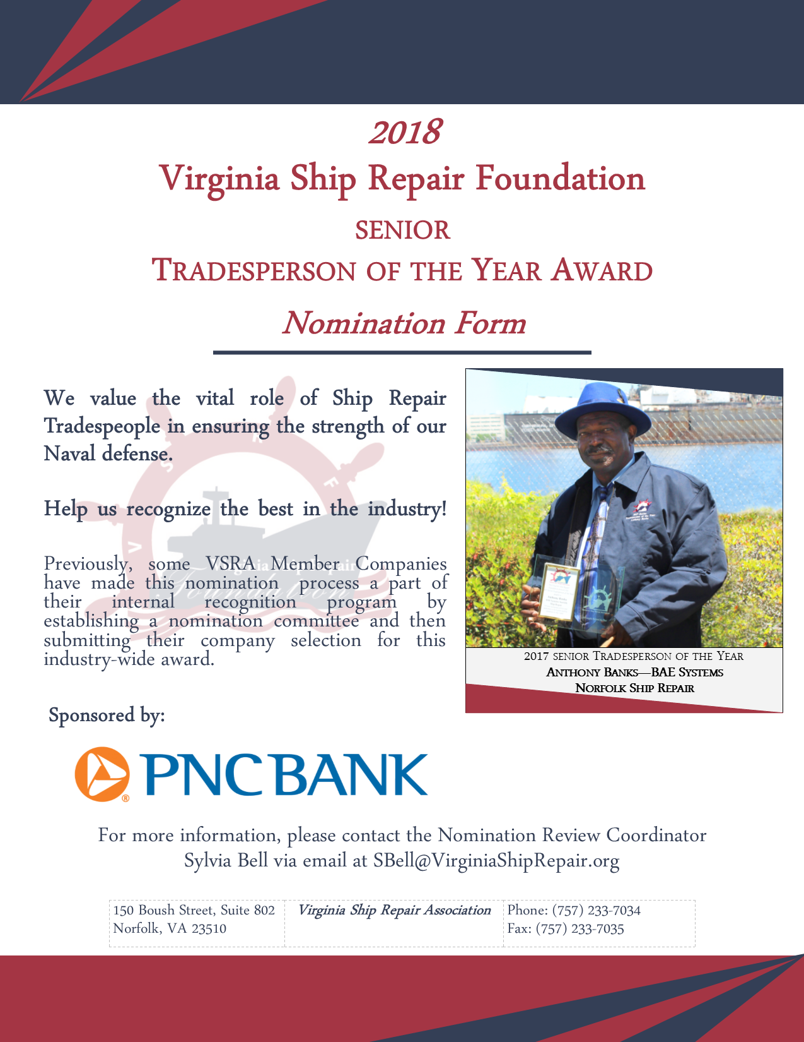
Virginia Ship Repair Foundation
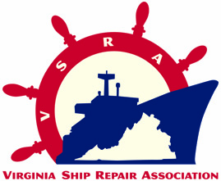
2018 SENIOR TRADESPERSON OF THE YEAR
(More than five years trade experience)
NOMINATION FORM
Only ONE Senior Tradesperson Nominee per company will be accepted.
INCOMPLETE NOMINATIONS WILL NOT BE CONSIDERED.

Please Note: This award is for recognition of a tradesperson; submissions for any non-tradesperson will not be considered. A tradesperson is a manual worker employed in a particular trade or craft requiring skill; this is contrasted with unskilled laborers and professionals (those in the learned profession).

Company Submitting Nomination: _________________________________________________
VSRA Member? YES☐ NO☐
Nominee’s Name: _______________________________________________________________
Nominee’s Trade Area: ___________________________________________________________
More than 5 years in trade? YES☐ NO☐
Nominee’s Current Job Title: ______________________________________________________
Nominee’s Jacket Size: Choose an item. Nominee’s Telephone Number: ___________________

Nominator’s Name: _____________________________________________________________
Nominator’s Job Title: ___________________________________________________________
Nominator’s Email: _______________________ Nominator’s Telephone Number: __________

SUBMISSION INSTRUCTIONS
Submit your completed nomination form via email, fax, or mail to the attention of Sylvia Bell:
Email: SBell@VirginiaShipRepair.org
Fax: 757-233-7035
Mail: 150 Boush Street, Suite 802, Norfolk, VA 23510

Please submit this application form by: Friday April 20, 2018 at 5:00 PM. No extensions will be made to the deadline and late nominations will not be accepted! If you have any questions please contact Sylvia Bell at SBell@VirginiaShipRepair.org.
PART I: PERFORMANCE STANDARDS

Please comment on performance for each standard, describe how the nominee has excelled in their field, and be sure to cite specific examples.

- Demonstrates proficiency in area of expertise.
Click here to enter text.

- Consistently performs at the highest level of quality.
Click here to enter text.

- Seeks training and improvement opportunities to enhance trade and operational expertise.
Click here to enter text.

- Maintains an exemplary safety record and instill safe working practices in co-workers / team.
Click here to enter text.

- Consistently shares expertise with less experienced co -workers.
Click here to enter text.

- Mentors less experienced workers on career development plans.
Click here to enter text.

- Shares feedback on improvements with supervisors.
Click here to enter text.

PART II: PROFESSIONAL REPRESENTATION OF THE SHIP REPAIR INDUSTRY

Please provide two specific examples of how this nominee has EXCELLED in their field, and how their actions have:
(a) resulted in a positive image for ship repair, and/or
(b) had a positive impact on the staffs’ work process or environment, and/or
(c) resulted in better service or products to clients.

- Example #1:
Click here to enter text.

- Example #2:
Click here to enter text.

PART III: PROFESSIONAL AND PERSONAL ACHIEVEMENTS

Please provide specific data and examples for each of the following, and be sure to include attachments that may assist in demonstrating the Nominee’s achievements in each area:

- Education and Training Achievements (include attachments)
Click here to enter text.

- Professional and Industry Leadership Achievements (include attachments)
Click here to enter text.

- Community Leadership Achievements (examples of mentorship, community contribution or leadership)
Click here to enter text.

PART IV: COMPANY AWARD AGREEMENT
Per a decision by the Virginia Ship Repair Foundation, the awardee category will receive a VSRA embroidered jacket, $750.00 and awards. In addition, the company submitting this nomination form agrees to give the nominee time to attend the VSRA General Membership Luncheon on Tuesday, May 15, 2018 where the winner will be announced and if the employee is the winner time to attend the Annual National Maritime Day Reception. The company may decide, at their discretion, to allow the paid day off and allow the employee to attend the luncheon on a regularly scheduled work day. Nominees may bring one guest of their choosing to each of the events; companies cover additional seats at their expense.

Authorizing Company Representative Signature Date

