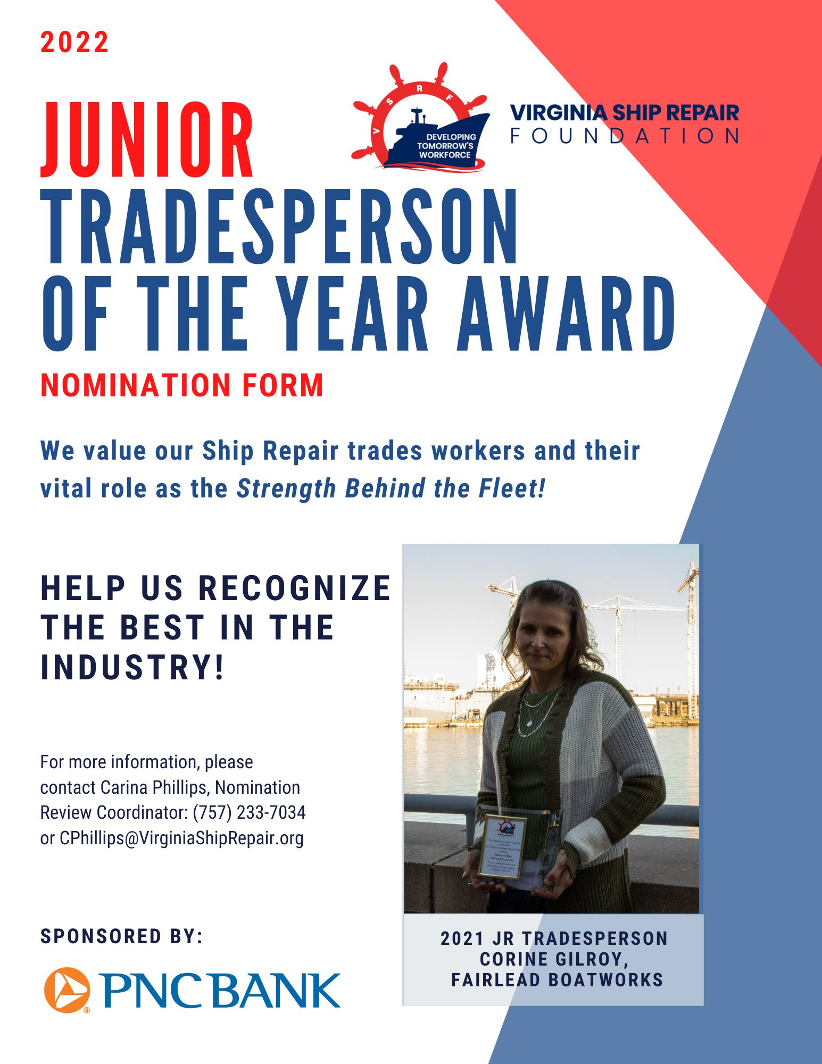
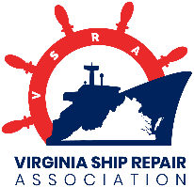
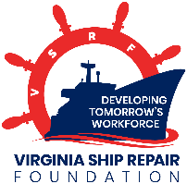
Virginia Ship Repair Foundation
2022 JUNIOR TRADESPERSON OF THE YEAR
(Fewer than five years of experience in trade)
NOMINATION FORM
Only ONE Junior Tradesperson Nominee per company will be accepted.
THIS AWARD IS OPEN TO VSRA MEMBER COMPANIES ONLY.
INCOMPLETE NOMINATIONS WILL NOT BE CONSIDERED.
Please Note: This award is for recognition of a tradesperson; submissions for any non-tradesperson will not be considered. A tradesperson is a worker employed in a particular trade or craft requiring skill.

Company Submitting Nomination: ________________________________________________________
NOMINEE INFORMATION
Nominee’s Name: Click here to enter text.
Nominee’s Trade Area: Click here to enter text.
Fewer than 5 years in trade? YES☐ NO☐ (Note: Total experience in trade, regardless of company affiliation)
Nominee’s Current Job Title: Click here to enter text.
Nominee’s Telephone Number: Click here to enter text. Nominee’s E-mail: Click here to enter text.
Nominee’s Jacket Size: Choose an item.
Please list the Nominee’s last three employers:
 | Company | Job Title | Duration of Employment
1 | Click here to enter text. | Click here to enter text. | Click here to enter text.
2 | Click here to enter text. | Click here to enter text. | Click here to enter text.
3 | Click here to enter text. | Click here to enter text. | Click here to enter text.

NOMINATOR INFORMATION
Nominator’s Name: Click here to enter text.
Nominator’s Job Title: Click here to enter text.
Nominator’s Email: Click here to enter text.
Nominator’s Telephone Number: Click here to enter text.

SUBMISSION INSTRUCTIONS
Ensure all prompts are fully answered. Incomplete nominations will not be considered. Submit your completed nomination form via e-mail or mail to the attention of Carina Phillips:
E-mail: CPhillips@VirginiaShipRepair.org
Mail: 101 West Main Street, Suite 5500, Norfolk, VA 23510
Please submit this application form by Friday, October 14, 2022 at 5:00 PM. No extensions will be made to the deadline and late nominations will not be accepted! If you have any questions, please contact Carina Phillips at CPhillips@VirginiaShipRepair.org.
PART I: PERFORMANCE STANDARDS
Nomination Tips: Please try to refrain from using the nominee’s name or company name in your nominee descriptions other than on the first page of the nomination form. Also please refrain from using HE or SHE within nominee descriptions, instead please use THEM, THEY, THEIR or NOMINEE as we want to maintain anonymity of the individual.
Please comment on performance for each standard, describe how the nominee has excelled in their trade, and be sure to cite specific examples.

- Cite specific examples of ways in which the nominee seeks training and improvement opportunities to enhance trade and operational expertise; provide examples of professional development achievements (e.g.: certifications, training, and specialized skills); include attachments as needed.
Click here to enter text.

- Cite specific examples of ways in which the nominee instills safe working practices in co-workers/team, including awards and recognitions earned.
Click here to enter text.

- Cite specific examples of ways in which the nominee consistently shares trade knowledge with less experienced co-workers.
Click here to enter text.

4. Cite specific examples of how nominee compares to their peers.
Click here to enter text.

PART II: PROFESSIONAL REPRESENTATION OF THE SHIP REPAIR INDUSTRY
Nomination Tips: Please try to refrain from using the nominee’s name or company name in your nominee descriptions other than on the first page of the nomination form. Also please refrain from using HE or SHE within nominee descriptions, instead please use THEM, THEY, THEIR or NOMINEE as we want to maintain anonymity of the individual.
Please describe how the nominee has been a positive representation of the ship repair industry, and be sure to cite specific examples.

- Provide examples of leadership, mentorship, and/or role modeling; include reference letters and other attachments as needed.
Click here to enter text.

- Provide examples of creativity or innovation on the job; include attachments as needed.
Click here to enter text.

- Provide examples of how the Nominee has been recognized by the company, customers or other organizations, either formally or informally (for instance, e-mail commendation from the ship’s force); include attachments as needed.
Click here to enter text.

- Provide examples of community leadership achievements within the past 12 months.
Click here to enter text.

- If this nominee is chosen as Jr. Tradesperson of the Year, describe how they would be a positive ambassador for VSRA and the ship repair industry.
Click here to enter text.

PART III: COMPANY AWARD AGREEMENT
The selected Tradesperson of the Year winner will be awarded a cash prize by VSRA and publicly recognized during the General Membership Luncheon and at various events throughout the year. In addition, the company submitting this nomination form agrees to give the nominee time to attend the VSRA General Membership Luncheon on Tuesday, November 15, 2022 where the winner will be announced. The company may decide, at their discretion, to allow the paid day off and allow the employee to attend the luncheon on a regularly scheduled workday. Nominees may bring one guest of their choosing to the event.

Authorizing Company Representative Signature Date

